Size of the Files

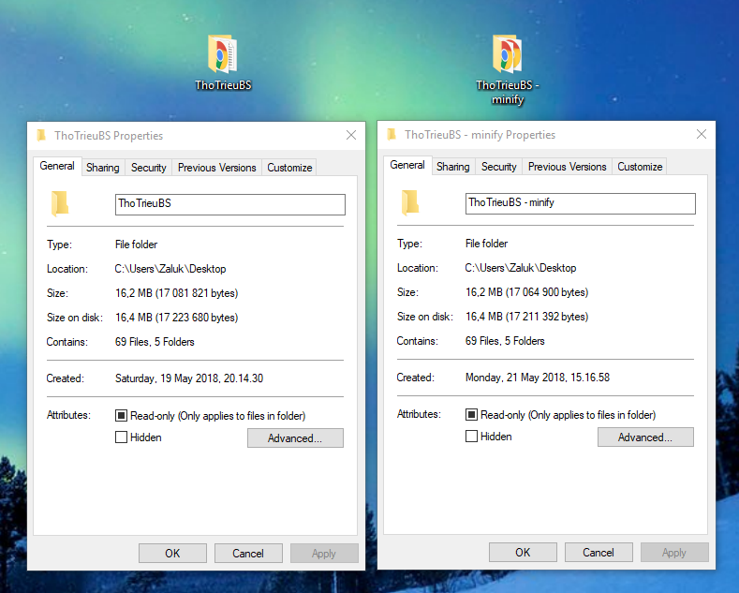

As we can see the image above, there are same files, the minified folder is lighter than the original.

Size of original files:

Original files for developing. Therefore, it is heavier than minified files but it is clearer to code.

Before minifying the code, its weight 17 223 680 bytes (16,4 MB)

Size of minified files:

After minifying the HTML,CSS and JS files, its weight is lighter.

It is 17 211 392 bytes (16,4MB)

Structure of the Pages:

Every page has the same navigation and footer which is responsive div, using Bootstrap framework of CSS.

For some smaller views, the content may not display full. It needs scrolling for more content.

At large views

Navigation always has Home Tab active.



Find Tab for searching.



Breadcrumb helps users can easily see where they are and be back to the place they want.



Footer has Introduction information with Contact information and Location Information.

For My location column, I use google map embedded code.



At smaller view

The navigation will be collapsed.



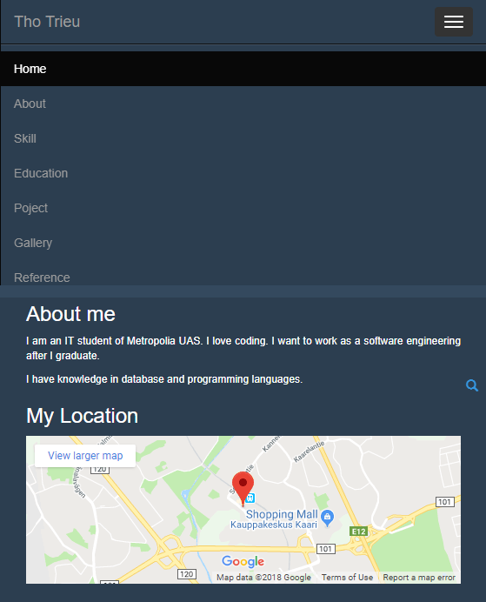

Searching bar will be minimized as well as footer and breadcrumb.

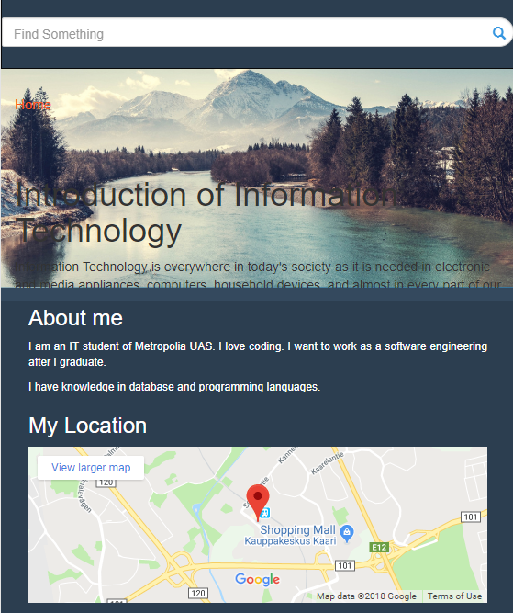



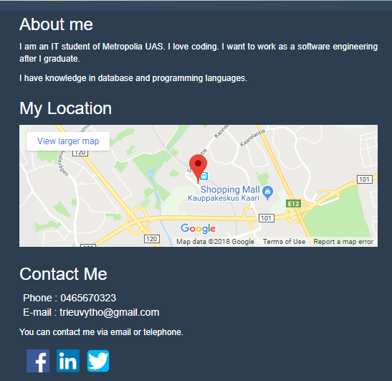

Pages

# Home Page

A picture for background.

### Extra small view (<560px)

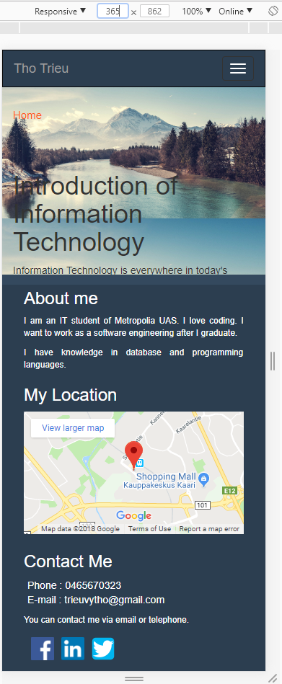

### Small view (560px)

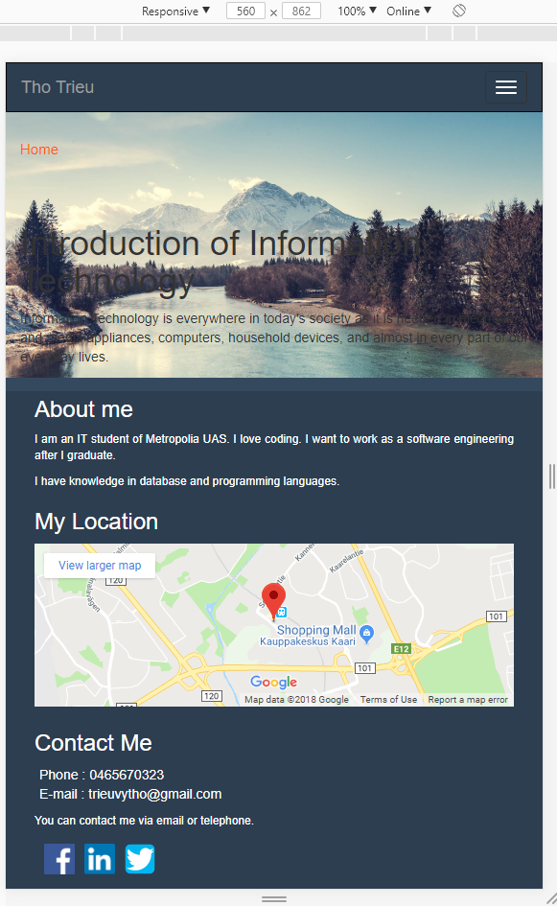

### Medium view (768px)

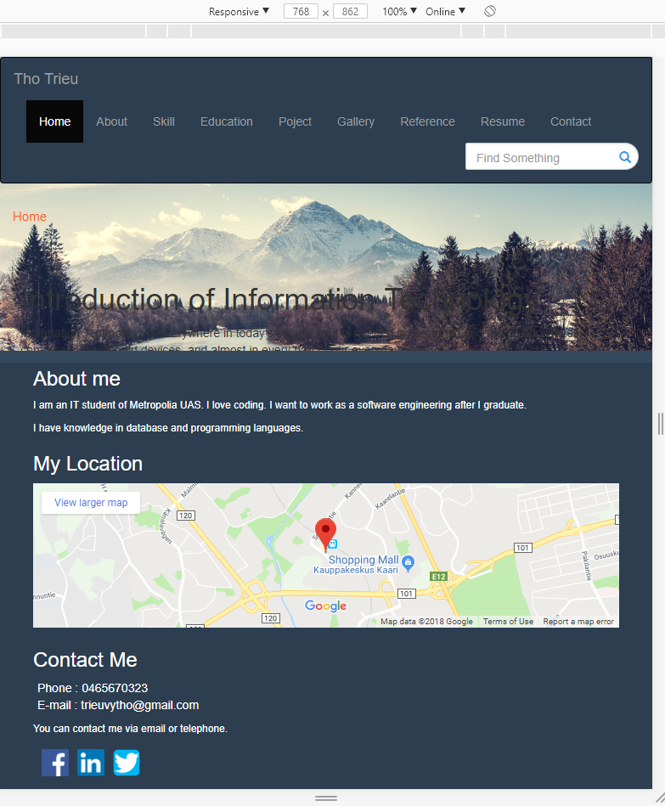

### Large view (992px)

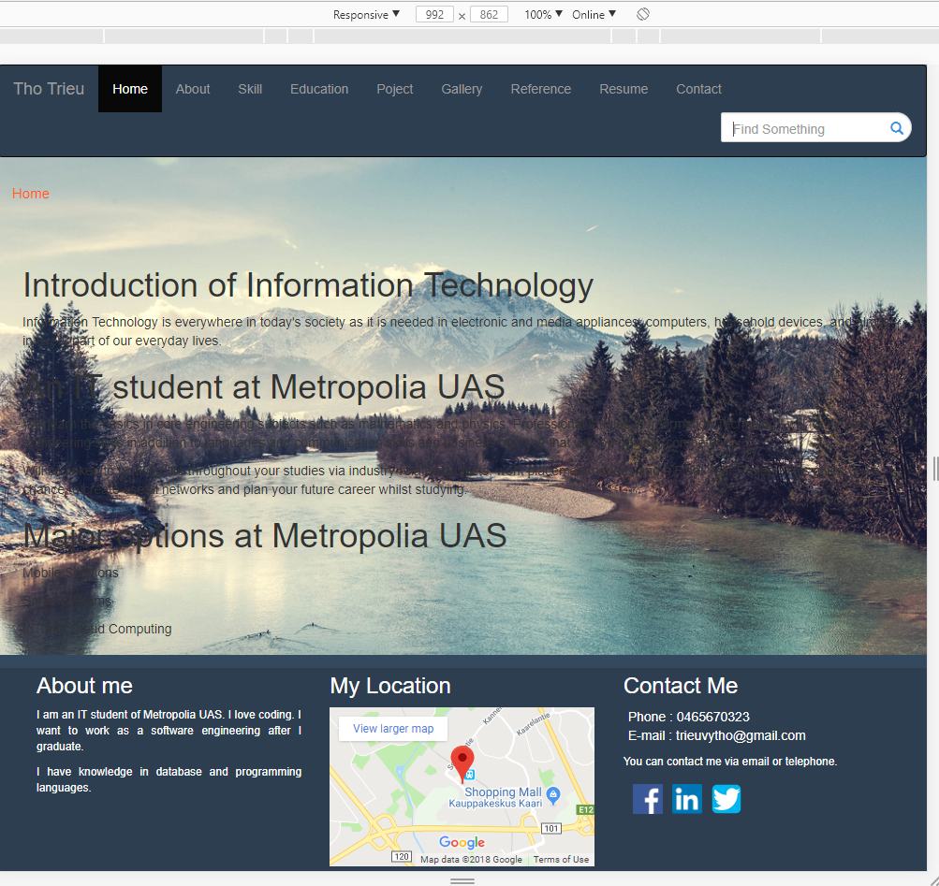

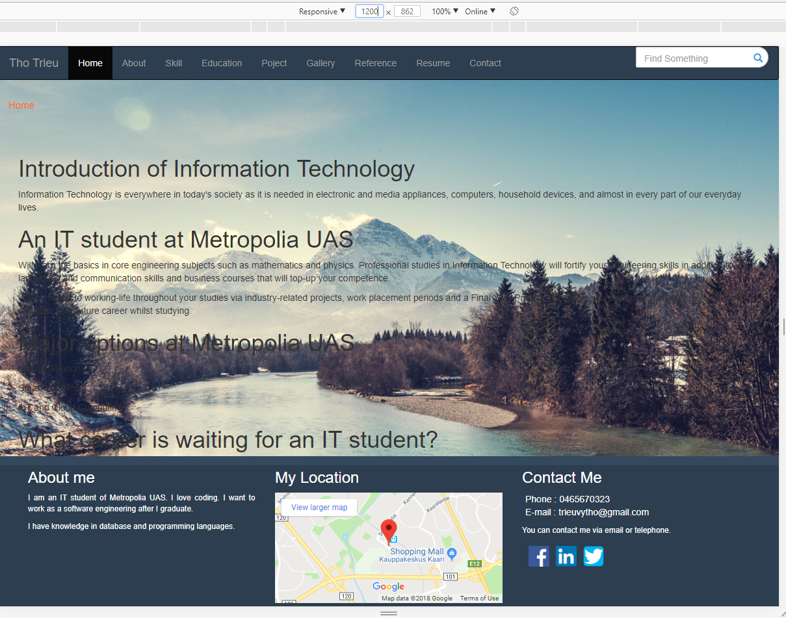

# About Page

Using jumbotron for introduction and hobbies.

### Extra small view (<560px)

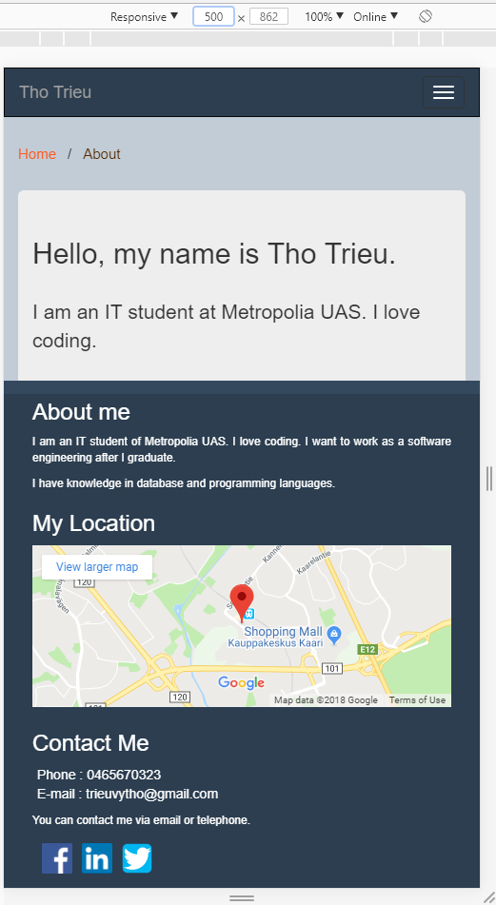

### Small view (560px)

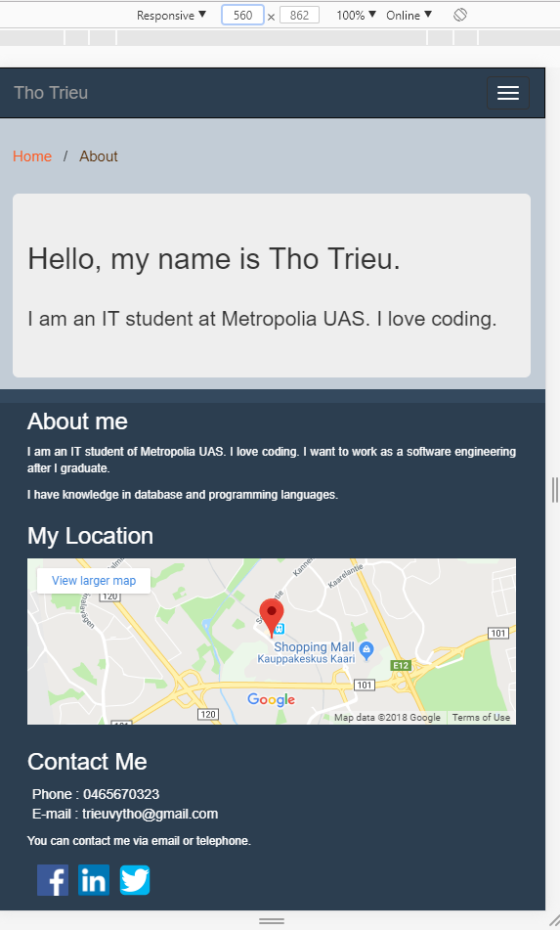

### Medium view (768px)

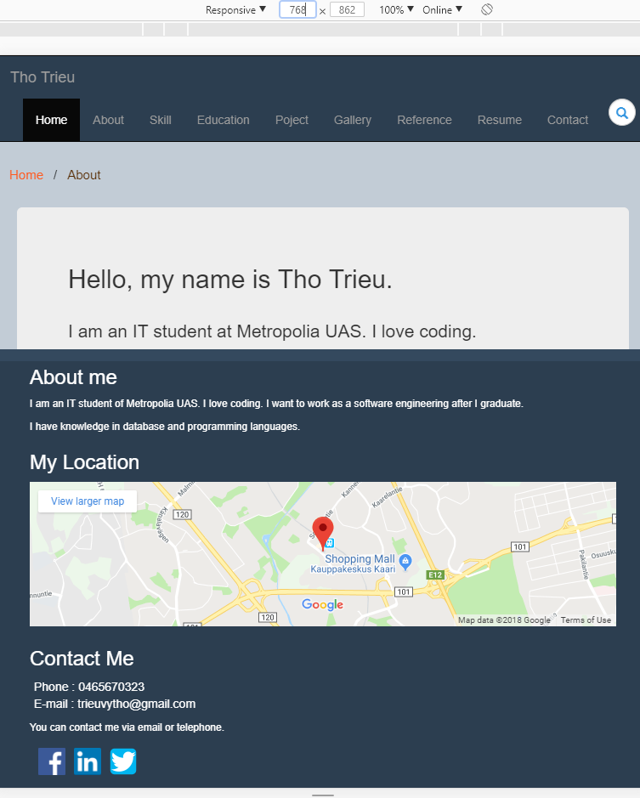

### Large view (992px)

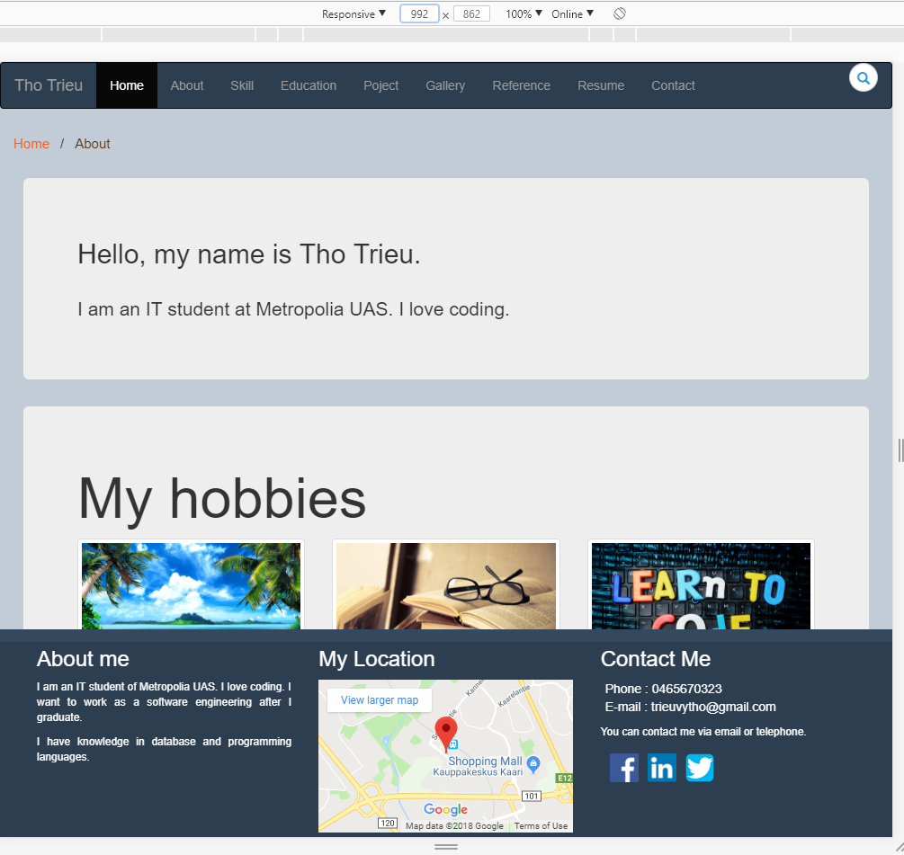

# Skill Page

Using progress bar to display the skills.

Using pull right class for displaying the percentage clearer on the above progress bar.

### Extra small view (<560px)

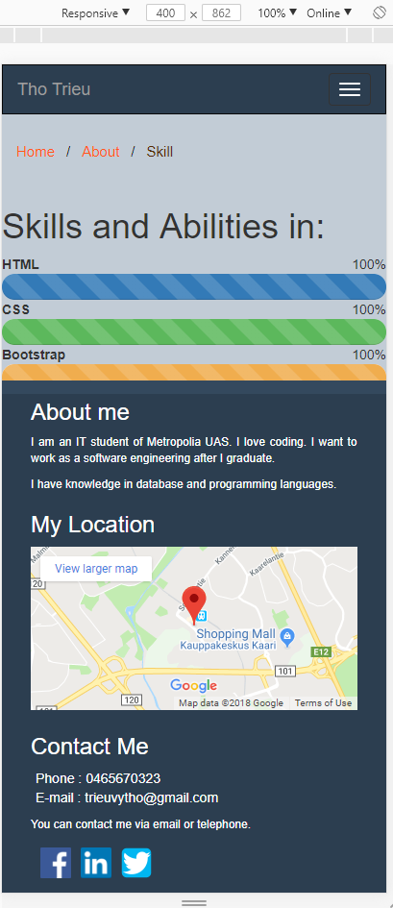

### Small view (560px)

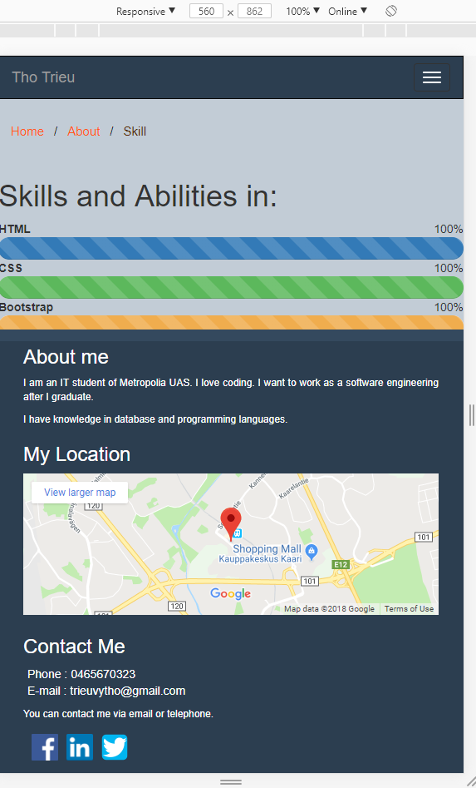

### Medium view (768px)

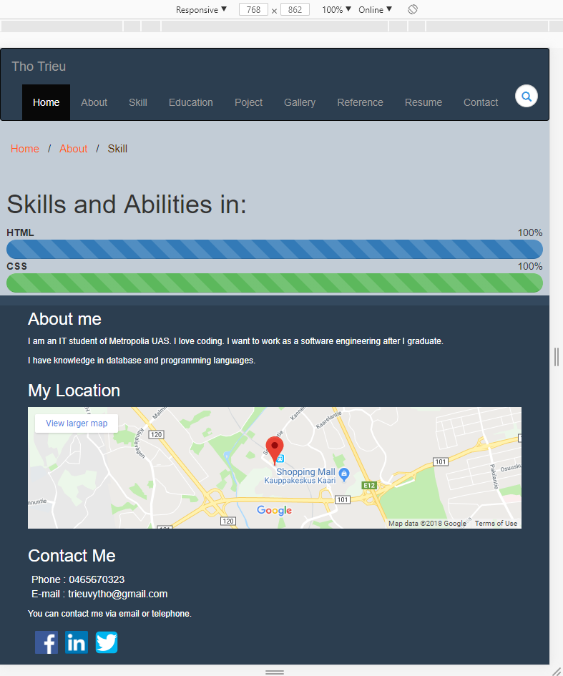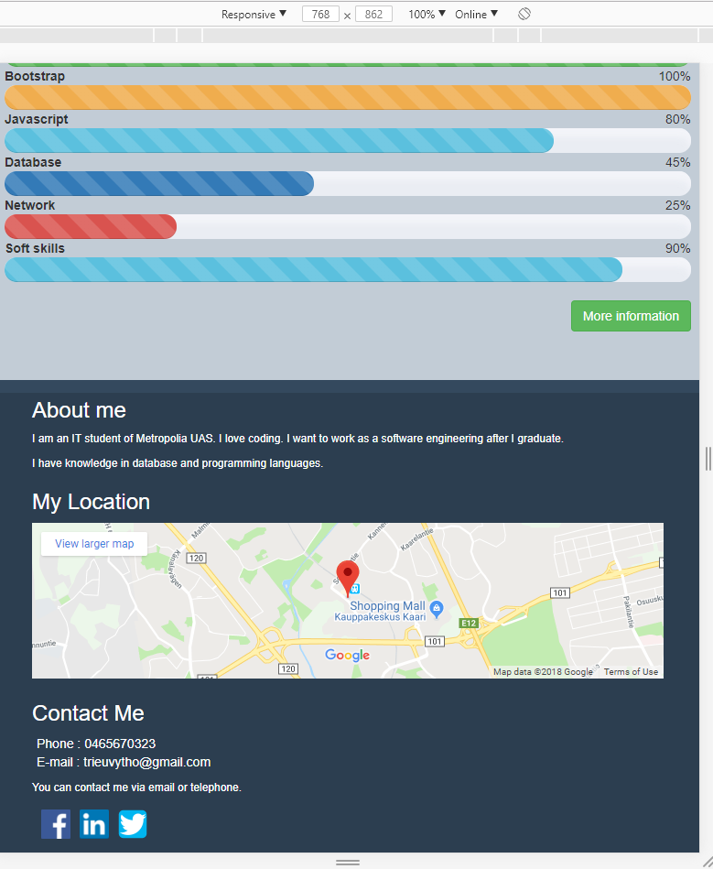

### Large view (992px)

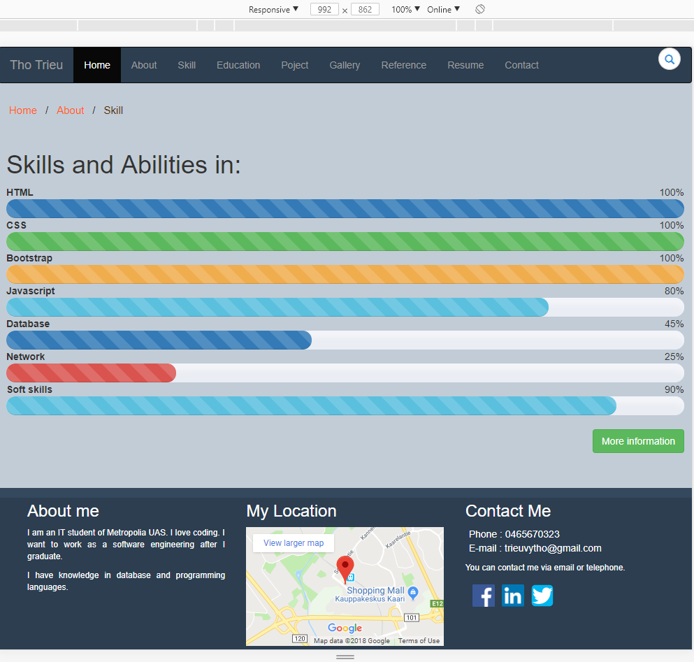

# Education Page

Using panel with heading, body and footer to display the information.

### Extra small view (<560px)

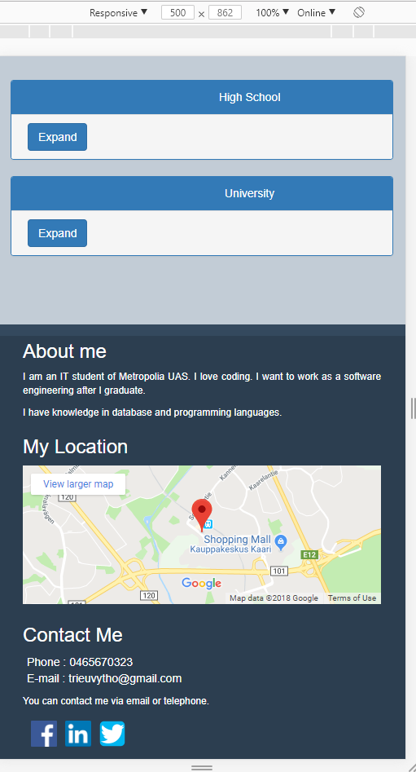 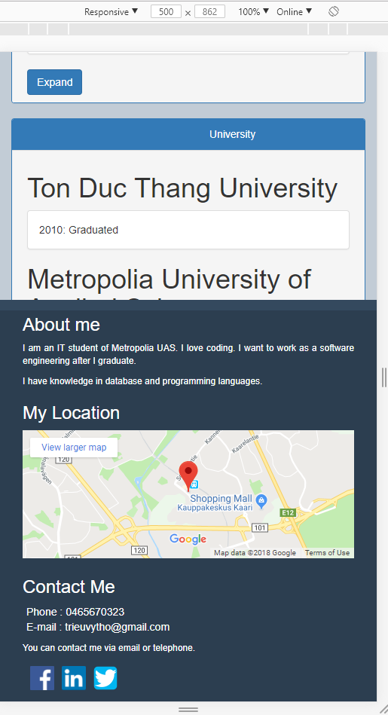

### Small view (560px)

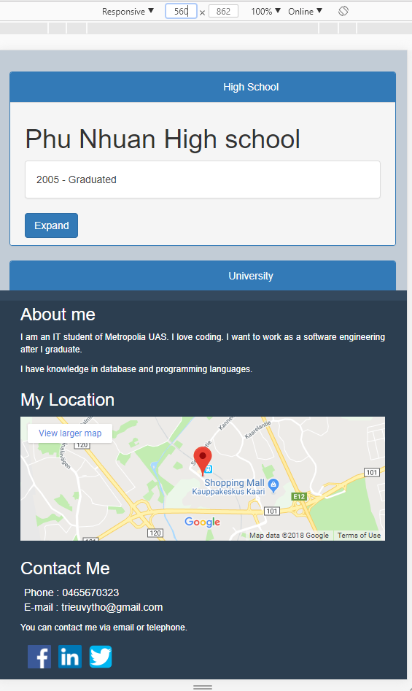

### Medium view (768px)

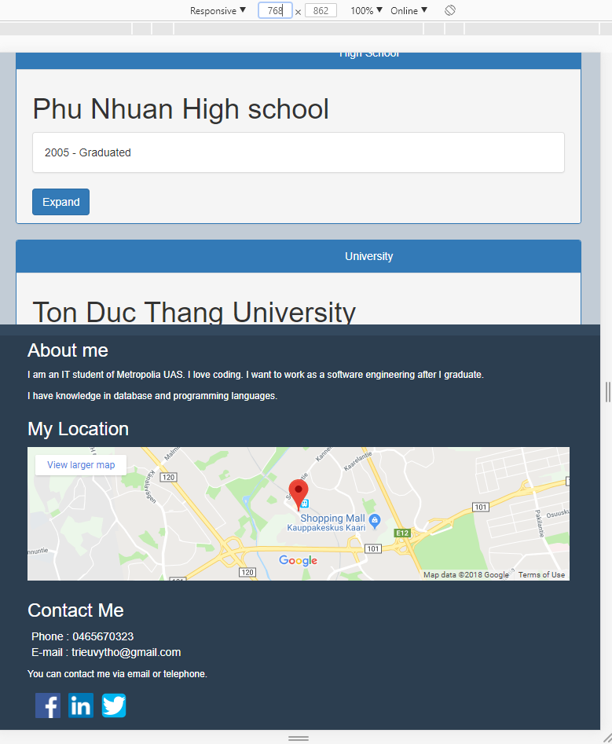

### Large view (992px)

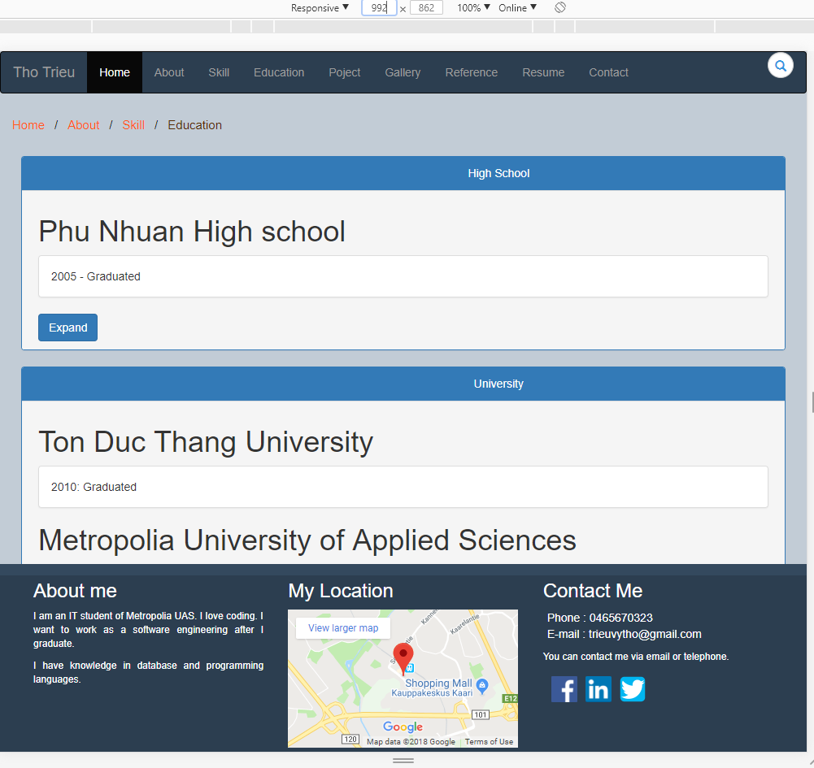

# Projects Page

Using panel with nav-tab to show 3 projects.

Every project has its own modal which contains specific content.

### Extra small view (<560px)

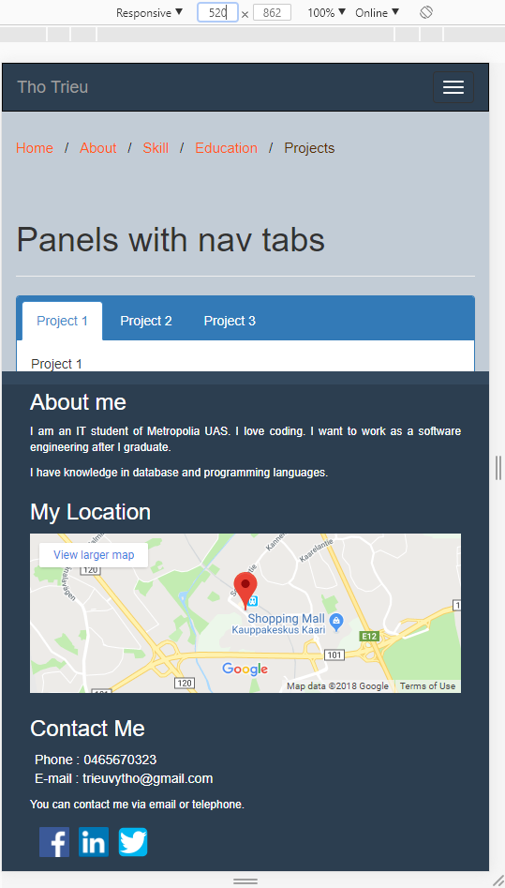 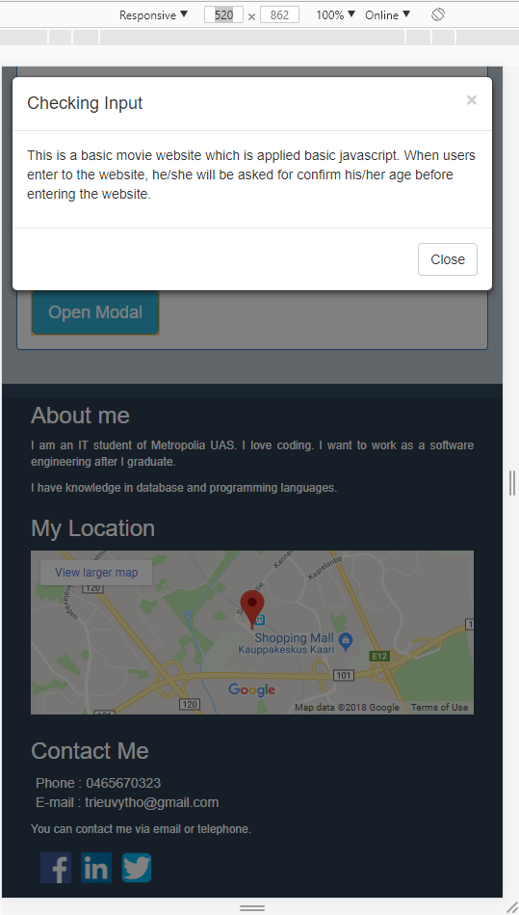

### Small view (560px)

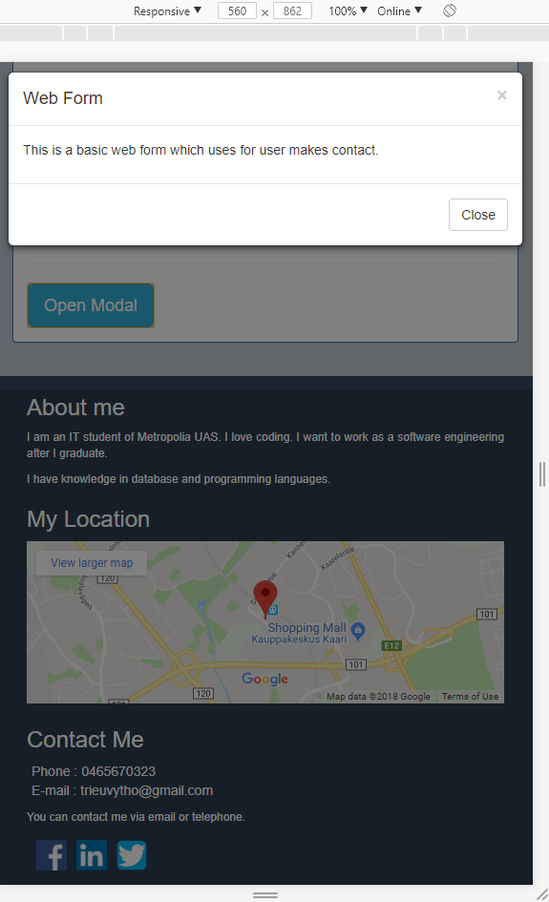

### Medium view (768px)

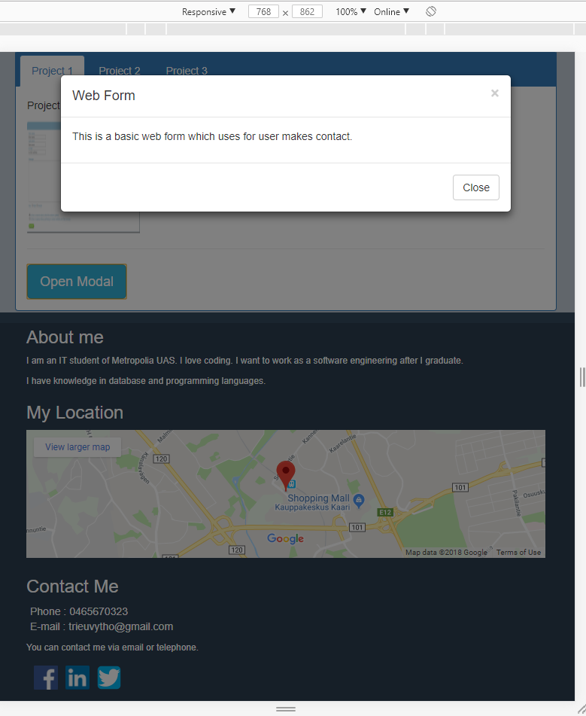

### Large view (992px)

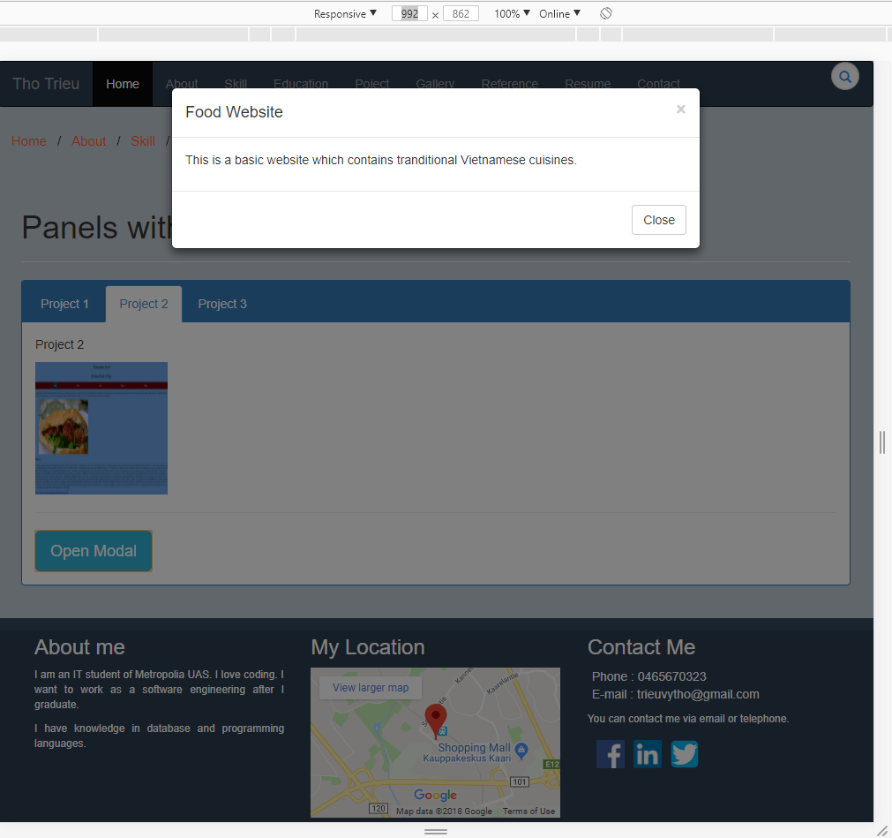

# Gallery Page

A gallery which contains image slider and video feature.

A slideshow contains thumbnail and the images respectively.

### Extra small view (<560px)

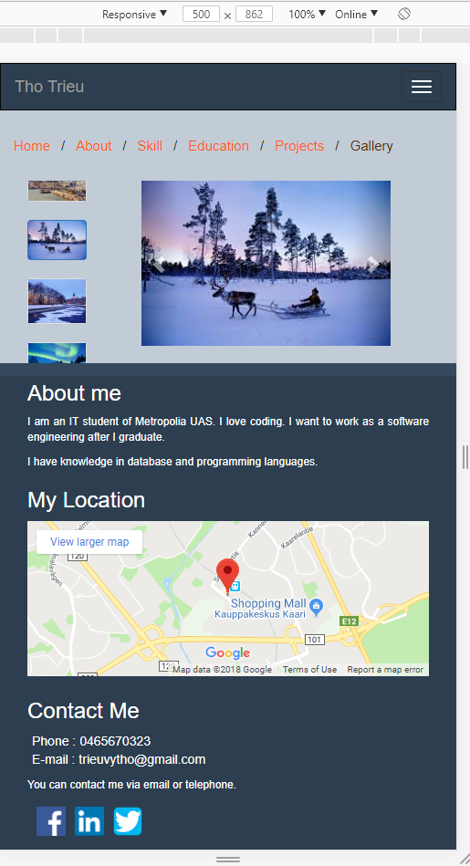 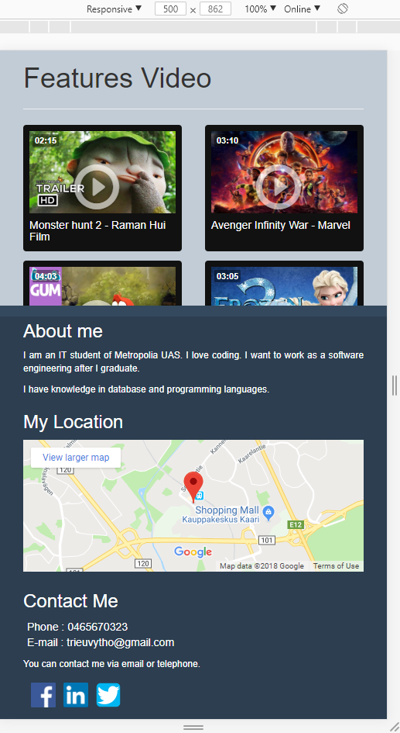

### Small view (560px)

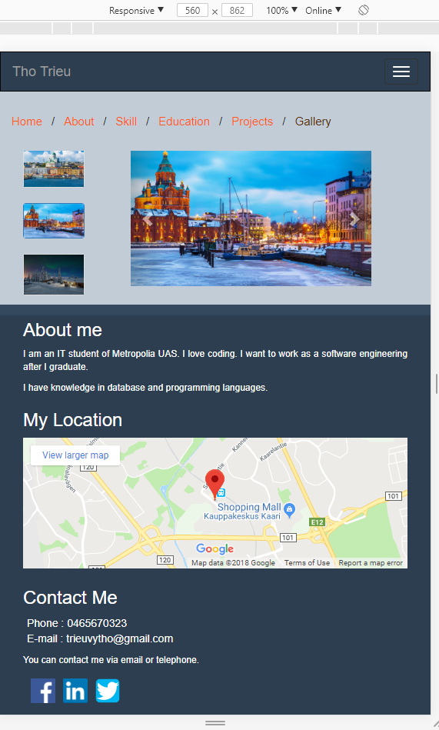 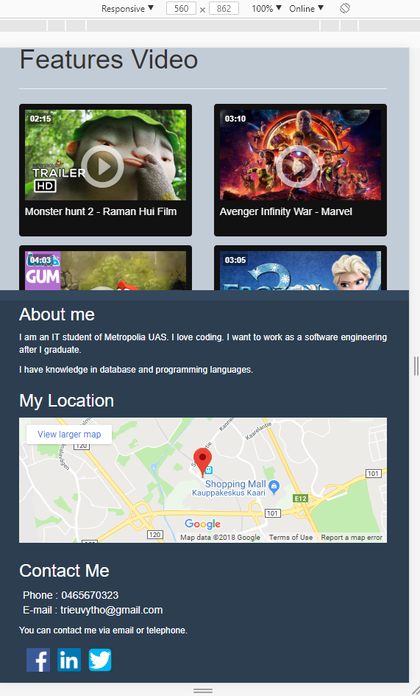

### Medium view (768px)

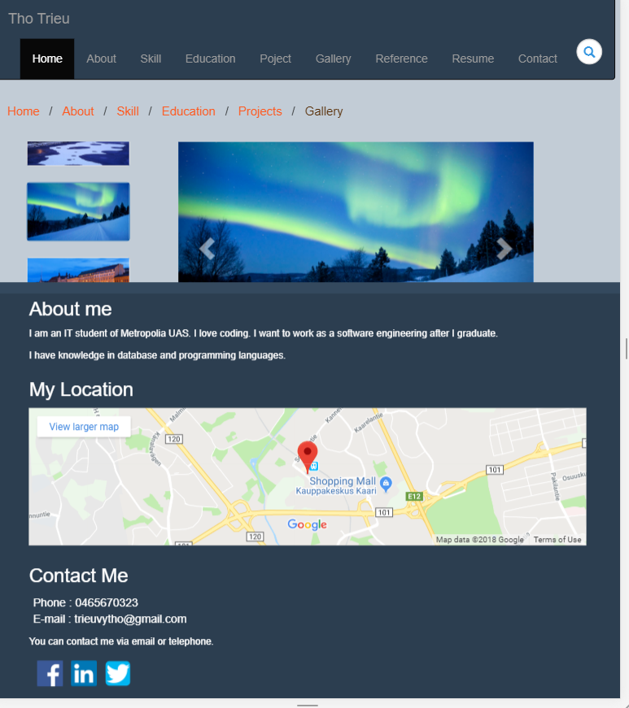

### Large view (992px)

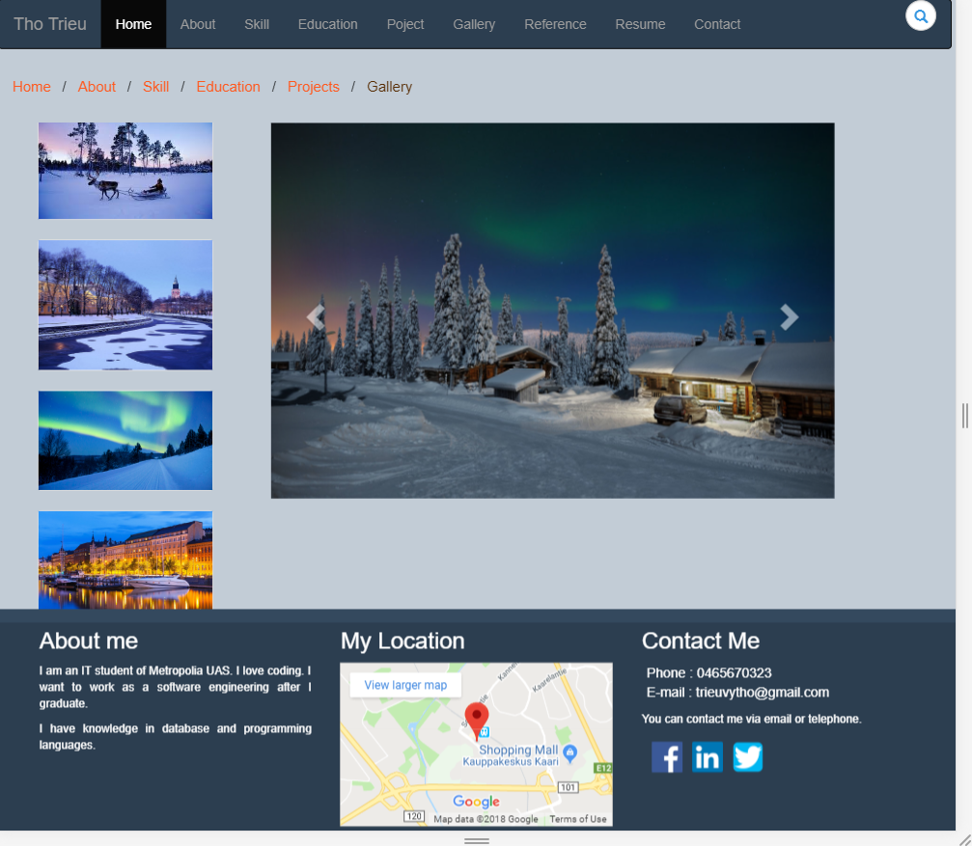

# Resume Page

In resume page, it contains a table with short description.

Then, users can download my CV at docx or pdf file if he/she want to see more details.

### Extra small view (365px)

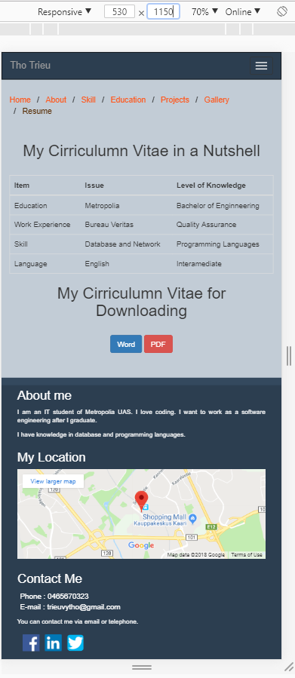

### Small view (560px)

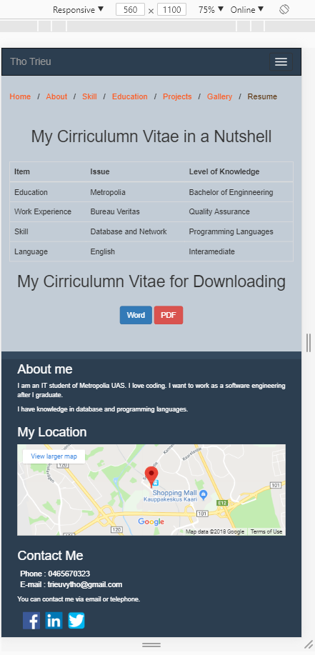

### Medium view (768px)

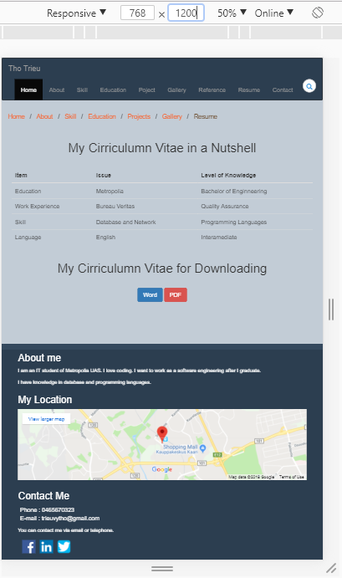

### Large view (992px)

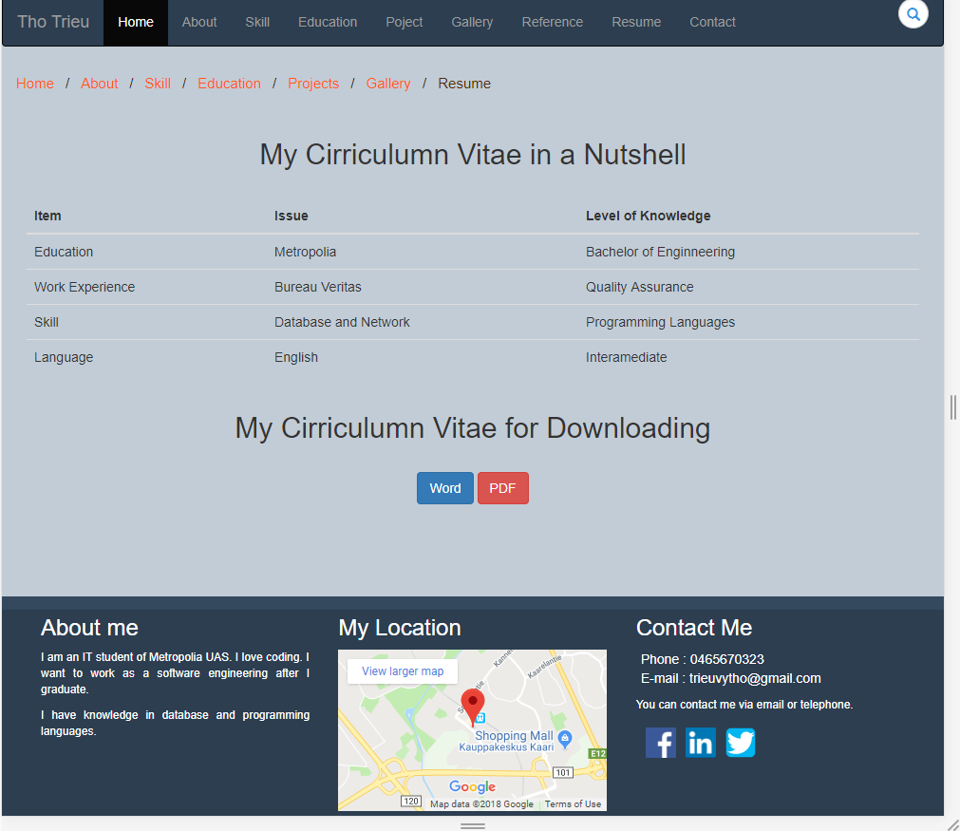

# Contact Page

Validation form as requirement.

When the value is accepted, it will be green. Otherwise, it will be red.

### Extra small view (<560px)

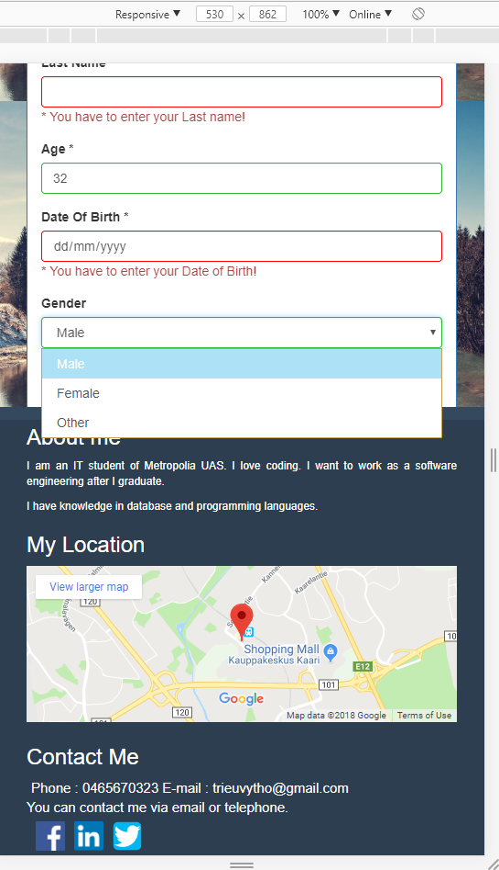

### Small view (560px)

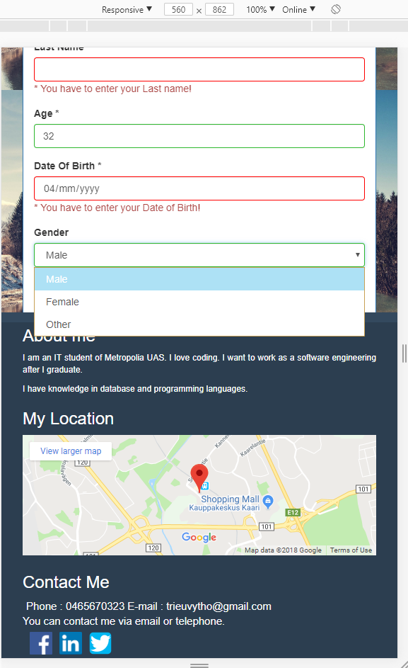

### Medium view (768px)

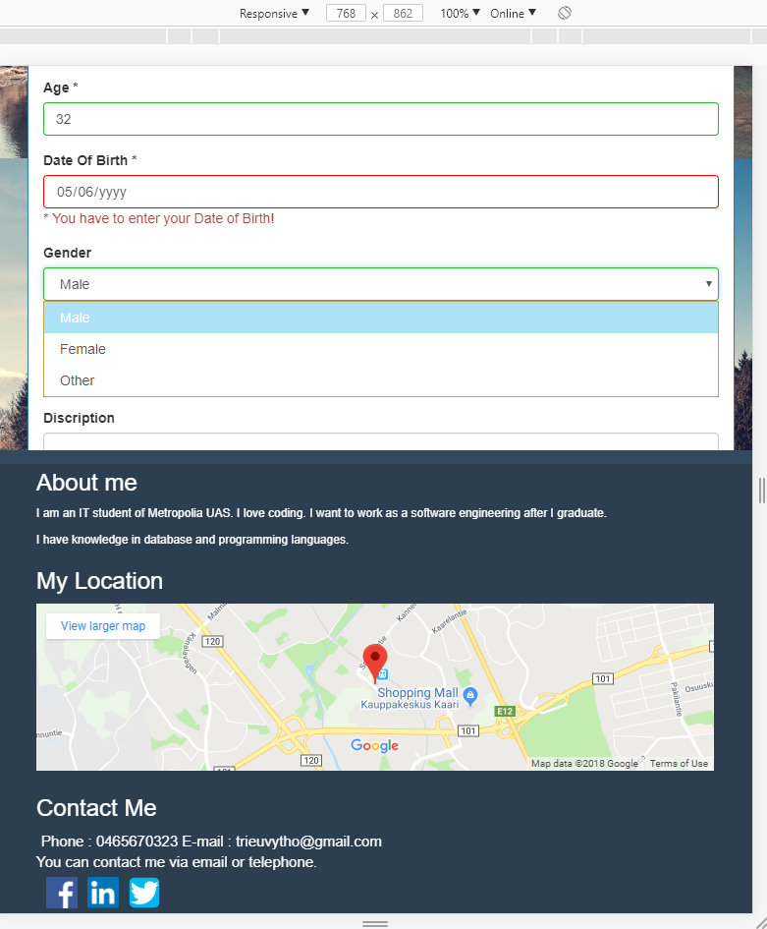

### Large view (992px)

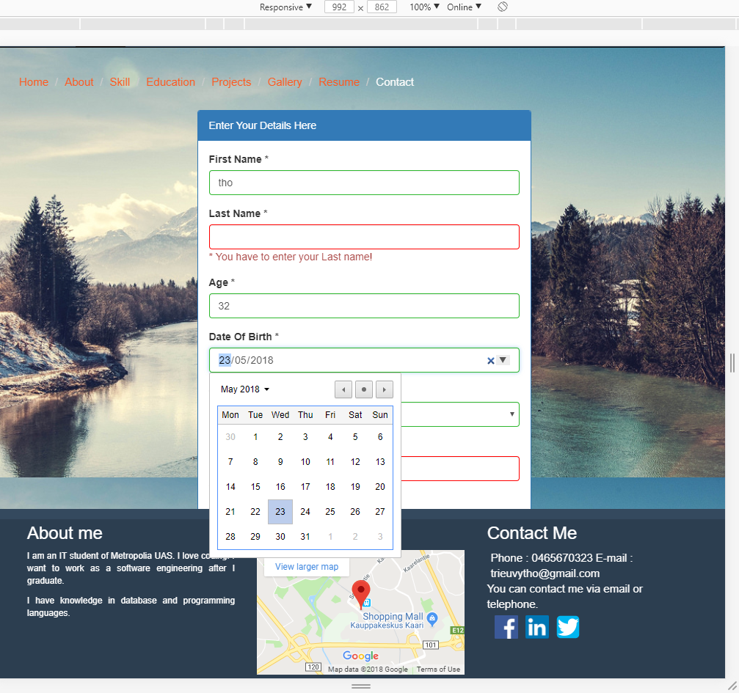

# Reference Page

This page using parallax rolling effect to introducing my information in short details. It also have a link ‘Back to Top’ so that the user can be at the top of page easily.

As w3school presents, Parallax scrolling is a web site trend where the background content (i.e. an image) is moved at a different speed than the foreground content while scrolling.

The parallax scrolling enables the smoothly effect while scrolling progress.

Here are the code lines:

<!DOCTYPE html>

<html lang="en">

<head>

<!-- Meta Tags for Bootstrap 4 -->

<meta charset="utf-8">

<meta name="viewport" content="width=device-width, initial-scale=1, shrink-to-fit=no">

<!-- Bootstrap 4 CSS -->

<link rel="stylesheet" href="https://maxcdn.bootstrapcdn.com/bootstrap/4.0.0/css/bootstrap.min.css" integrity="sha384-Gn5384xqQ1aoWXA+058RXPxPg6fy4IWvTNh0E263XmFcJlSAwiGgFAW/dAiS6JXm" crossorigin="anonymous">

<style>

/* Header Parallax Element Style*/

.paral {

min-height: 600px;

background-attachment: fixed;

background-size: cover;

background-position: 50% 50%;

}

/* Paragrapgh for Parallax Section */

.paral p {

font-size: 24px;

color:#f5f5f5;

text-align: center;

line-height: 60px;

}

/* Heading for Parallax Section */

.paral h1 {

color: rgba(255, 255, 255, 0.8);

font-size: 60px;

text-align: center;

padding-top: 60px;

line-height: 100px;

}

/* Image for Parallax Section */

.paralsec {

background-image: url("img/aurora.jpg");

}

.paralsec1 {

background-image: url("img/book.jpg");}

.paralsec2 {

background-image: url("img/travel.jpg");

}

.paralsec3 {

background-image: url("img/contact.jpg");

}

/* Remove Bottom Margin from Jumbotron */

.jumbotron{margin-bottom: 0;}

/* Footer */

.wn-footer {

padding: 2.5rem 0;

text-align: center;

color: white;

background-color: #557899;

border-top: .05rem solid #e5e5e5;

}

.wn-footer a {

color: #ea6b10;

}

</style>

</head>

<body>

<!-- First Parallax Section -->

<div class="jumbotron paral paralsec">

<h1 class="display-3">About me</h1>

<p class="lead">My name is Tho Trieu. I am studying at Metropolia UAS - Information Technology Major.</p>

<p class="lead">

<a class="btn btn-info btn-lg btn-md" href="file:///C:/Users/Zaluk/Desktop/ThoTrieuBS/about.html" role="button">More details</a>

</p>

</div>

<!-- Second Parallax Section -->

<div class="jumbotron paral paralsec1">

<h1 class="display-3">What can I do?</h1>

<p class="lead">I have knowledge in database, network and programming language such as Javascript, PHP, C/C++, Python, etc.</p>

<p class="lead">

<a class="btn btn-warning btn-lg btn-md" href="file:///C:/Users/Zaluk/Desktop/ThoTrieuBS/skill.html" role="button">More details</a>

</p>

</div>

<!-- Third Parallax Section -->

<div class="jumbotron paral paralsec2">

<h1 class="display-3">What did I do?</h1>

<p class="lead">Please find out more by my projects</p>

<p class="lead">

<a class="btn btn-success btn-lg btn-md" href="file:///C:/Users/Zaluk/Desktop/ThoTrieuBS/project.html" role="button">More details</a>

</p>

</div>

<div class="jumbotron paral paralsec3">

<h1 class="display-3">Contact Me</h1>

<p class="lead">Please feel free to contact me</p>

<p class="lead">

<a class="btn btn-primary btn-lg btn-md" href="file:///C:/Users/Zaluk/Desktop/ThoTrieuBS/contact.html" role="button">Contact Me</a>

</p>

</div>

<!-- Footer Section -->

<footer class="wn-footer">

<p>

<a href="#">Back to top</a>

</p>

</footer>

<!-- Bootstrap 4 Scripts -->

<script src="https://code.jquery.com/jquery-3.2.1.slim.min.js" integrity="sha384-KJ3o2DKtIkvYIK3UENzmM7KCkRr/rE9/Qpg6aAZGJwFDMVNA/GpGFF93hXpG5KkN" crossorigin="anonymous"></script>

<script src="https://cdnjs.cloudflare.com/ajax/libs/popper.js/1.12.9/umd/popper.min.js" integrity="sha384-ApNbgh9B+Y1QKtv3Rn7W3mgPxhU9K/ScQsAP7hUibX39j7fakFPskvXusvfa0b4Q" crossorigin="anonymous"></script>

<script src="https://maxcdn.bootstrapcdn.com/bootstrap/4.0.0/js/bootstrap.min.js" integrity="sha384-JZR6Spejh4U02d8jOt6vLEHfe/JQGiRRSQQxSfFWpi1MquVdAyjUar5+76PVCmYl" crossorigin="anonymous"></script>

</body>

</html>

</body>

</html>

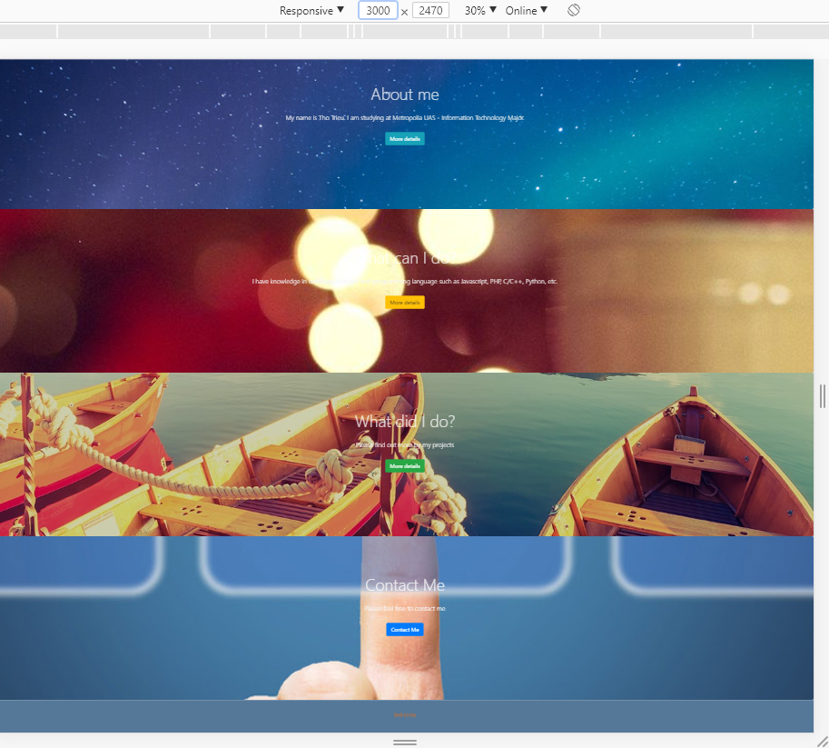

### Extra small view (<560px)

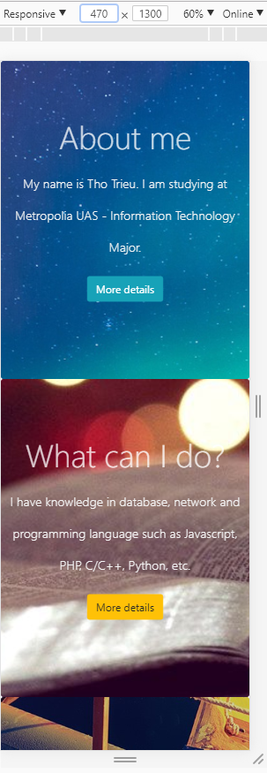

### Small view (560px)

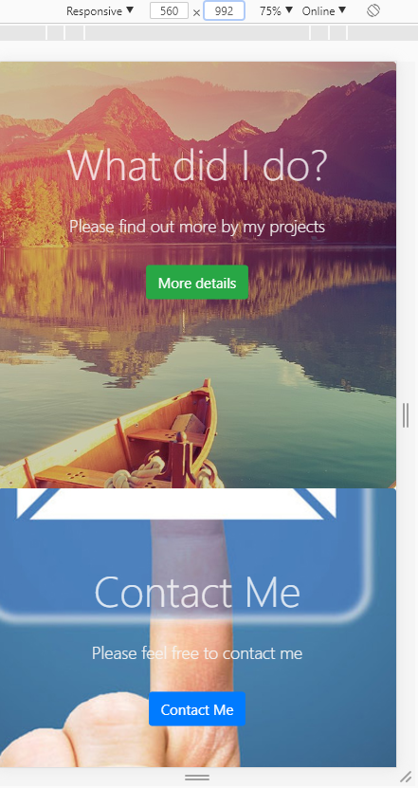

### Medium view (768px)

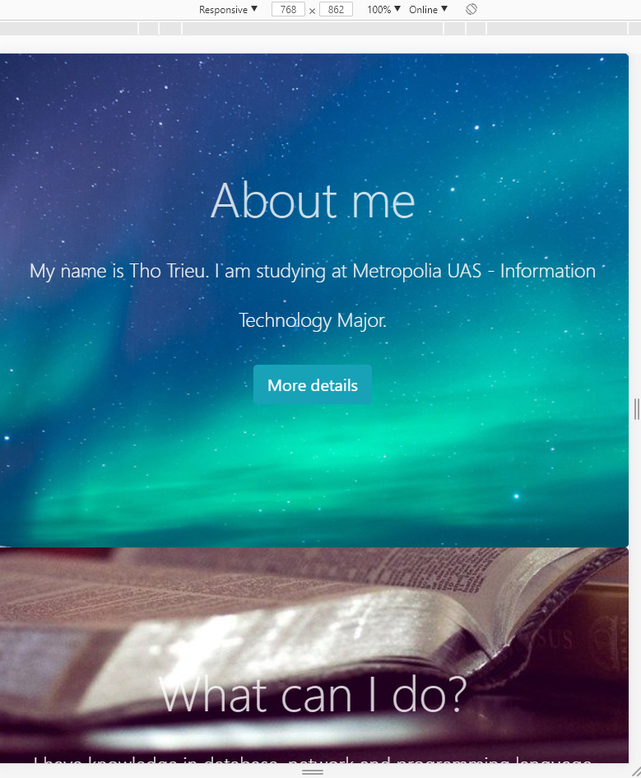

### Large view (992px)

